**Exercise 2: Implementing Dependency Injection**

**Scenario:** In the library management application, you need to manage the dependencies between the BookService and BookRepository classes using Spring's IoC and DI.

Steps:

1. Modify the XML Configuration:

* Update applicationContext.xml to wire BookRepository into BookService.

2. Update the BookService Class:

* Ensure that BookService class has a setter method for BookRepository.

3. Test the Configuration:

* Run the LibraryManagementApplication main class to verify the dependency injection.

**IMPLEMENTAION:  
  
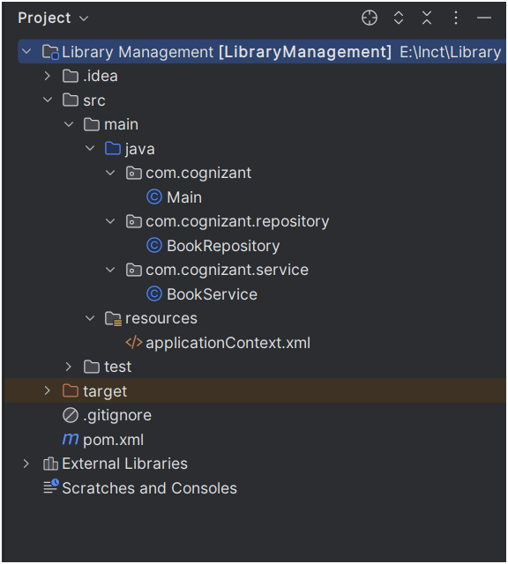**

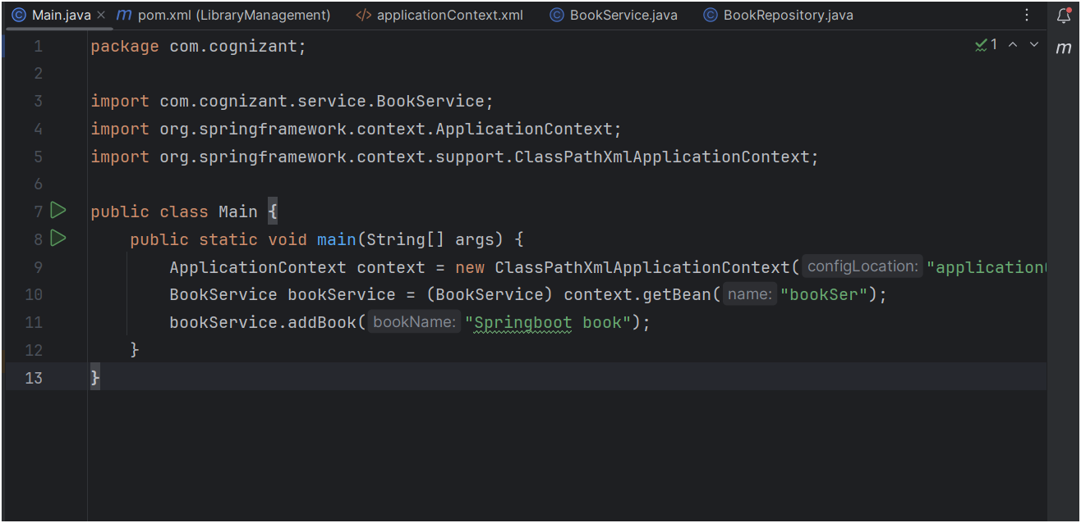

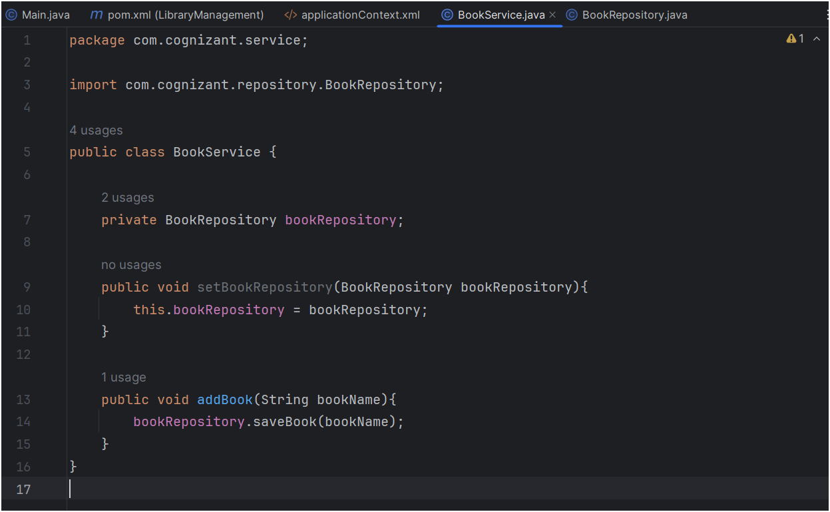

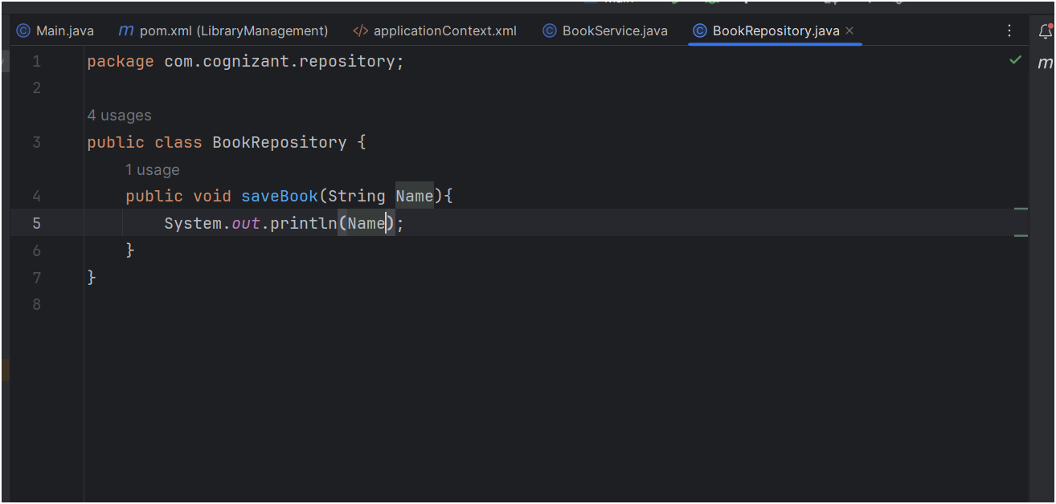

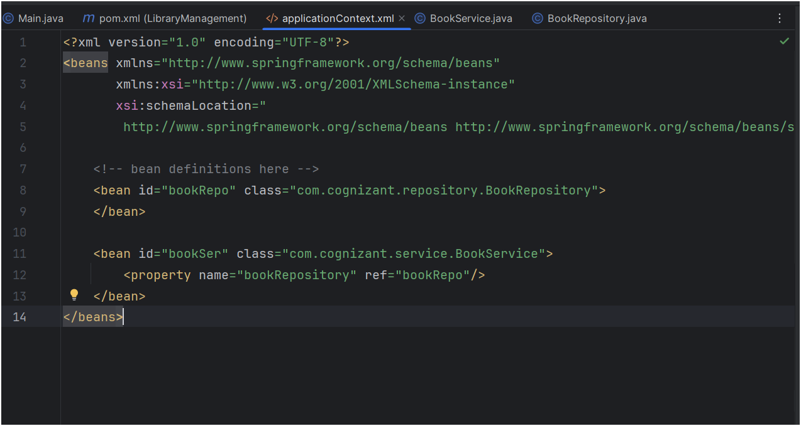

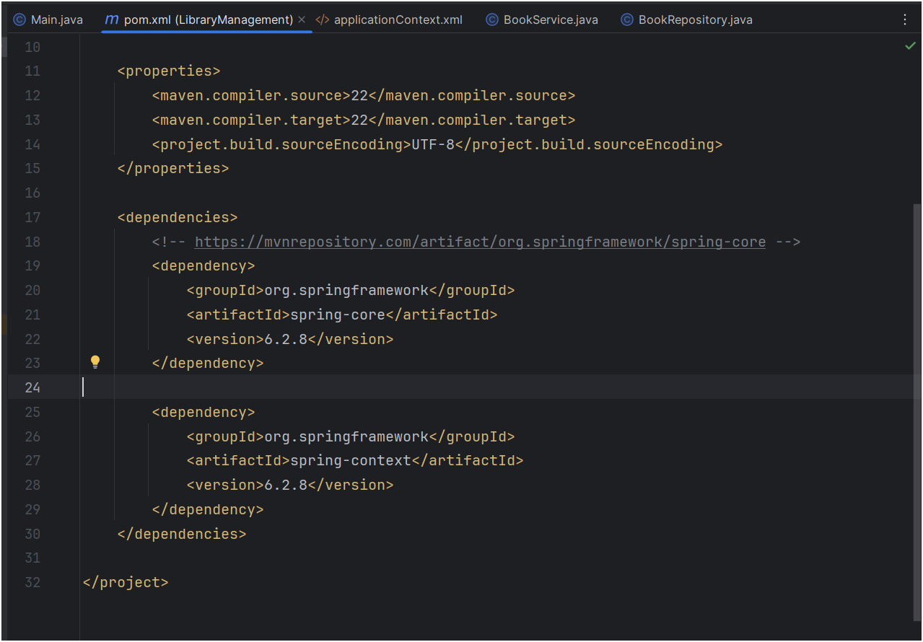

OUTPUT :  
  
